The GoMOOS Moored Buoy Design

John P. Wallinga
University of Maine
Orono, ME 04469
(207) 581-4321/(207) 581-4332
johnw@fram.umeoce.maine.edu

Neal R. Pettirew
University of Maine
Orono, ME 04469
(207) 581-4384/(207) 581-4332
nealp@maine.edu

James D. Irish
Woods Hole Oceanographic Institution
Woods Hole, MA 02543
(508) 289-2732/(508) 457-2195
jirish@whoi.edu

Abstract- The Gulf of Maine Ocean Observing System (GoMOOS) was started in part as a prototype for sustained regional ocean observing systems in energetic environments. The central observational element of GoMOOS is the real-time buoy array deployed in a region with very little history of successful year-round scientific surface mooring deployments. In addition, a sustained observing system needed an electrical and mechanical buoy architecture that could accommodate additional payloads, and the emerging sensors and technologies expected to be available over the next 5-10 years.
The GoMOOS Buoy system was designed with these general guidelines in mind, and is capable of accommodating on the order of 100 surface and subsurface sensors. The buoy is stable enough to perform with several hundred pounds of ice on its superstructure, and a technician can safely stand on the float to perform maintenance in light seas. The buoy is approximately 2 m in diameter and is deployable from relatively small research and fishing vessels.

I. INTRODUCTION

The Gulf of Maine is an economically vital, biologically rich, and physically diverse oceanographic and climatological environment. Spanning approximately 7,500 miles of coast line, 36,000 square miles of ocean, and surrounding approximately 5,000 islands from the Bay of Fundy to Cape Cod Bay, the Gulf of Maine’s high primary productivity has made this marginal sea one of the most productive fishing grounds on the Northeastern Seaboard. The Gulf’s complex array of banks and other submarine features range in depth from 4 to 500 meters. The basin’s geometry, near resonant response to the North Atlantic tide [1], buoyancy-driven mean circulation [2], and extreme weather conditions combine to provide a unique local environment for multi-disciplinary study and observation.
In 2000, a consortium of research and educational institutions, non-profit organizations, federal and state agencies, and commercial interests addressed the need for real-time monitoring of the meteorology and oceanography. A national pilot program, initially funded by the National Oceanographic Partnership Program, developed the Gulf of Maine Ocean Observing System (GoMOOS) as a working prototype for a regional ocean observing system utilizing satellites, long-range HF Radar for current measurement (CODAR), and a moored buoy array.
There are presently 10 mooring sites in the Gulf of Maine. The University of Maine has designed and constructed a total of 21 buoys, 2 for each of the 10 sites (rotated at six-month intervals) and an extra buoy for emergency response. Buoy locations are shown in Figure 1.
II. BUOY DESIGN

The GoMOOS project provided an opportunity to design a buoy that would meet both the present and future needs of a sustained ocean observing system. The list of design parameters, thus conceived, naturally grouped into three broad categories: payload, logistical considerations, and buoy hydrodynamical response characteristics.

The buoy is solar powered, and a large part of its payload requirements are related to the power system. The system consists of two rechargeable 12 V dc power supply with a 160 Ah capacity, trickle charged by 4-forty-watt solar panels. The onboard batteries supply power to all the buoy electronics: these include the communication and positioning systems, a micro-processor, controller, digital and analog sensors, and navigational aids. The power system is designed and packaged to fit inside a water tight well. 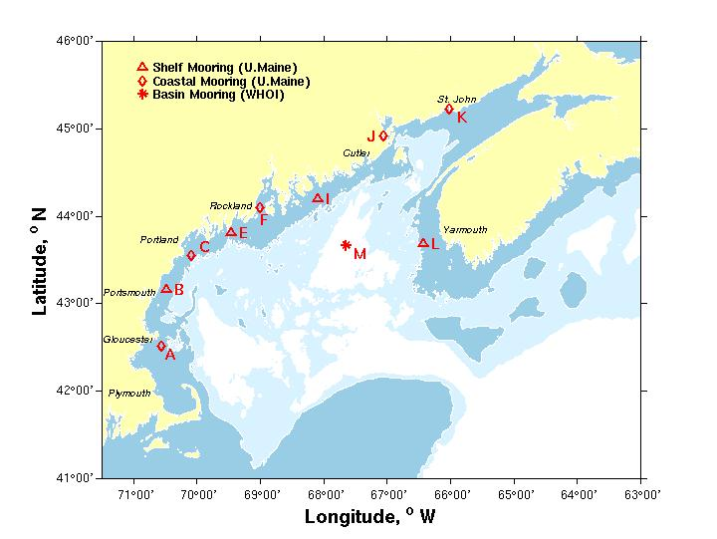
Fig. 1. The Gulf of Maine showing the coast line, 100,
and 200 meter isobaths and the GoMOOS buoy locations (in red).

The buoy must be large enough to be visible by sight and radar at approximately 2 nautical miles with a strong and reliable lamp, yet small enough to handle from relatively small vessels and fishing boats in the region.
The structural members of the buoy must be constructed from nonferrous material (due to the onboard compass), able to withstand the transient and dynamic loads during deployment and recovery operation, and survive the constant stress of the environment, the occasional hurricane or hurricane-force Nor’easters, and not infrequent contact with vessels. There should be enough reserve buoyancy to survive submersion as well as “float” the anchor should the mooring be dragged to deeper water.
The overall design of the buoy had to be as cost effective as possible. They are built from independent components that are easily fabricated from standard materials with minimal machining and welding to reduce total man hours. This design facilitates component replacement, upgrades, and repairs. Based on the first two design parameters, the buoy was constructed from seven components. Those include a self standing base with lead-filled legs (one component of the fixed ballast), a mooring bail for a single point attachment, a flotation collar, a well assembly to house the electronics with pad-eyes for handling and an adjustable ballast tube, a tower with shelves for mounting sensors and antennas, solar panel mounts, and guard ring (Figure 2).
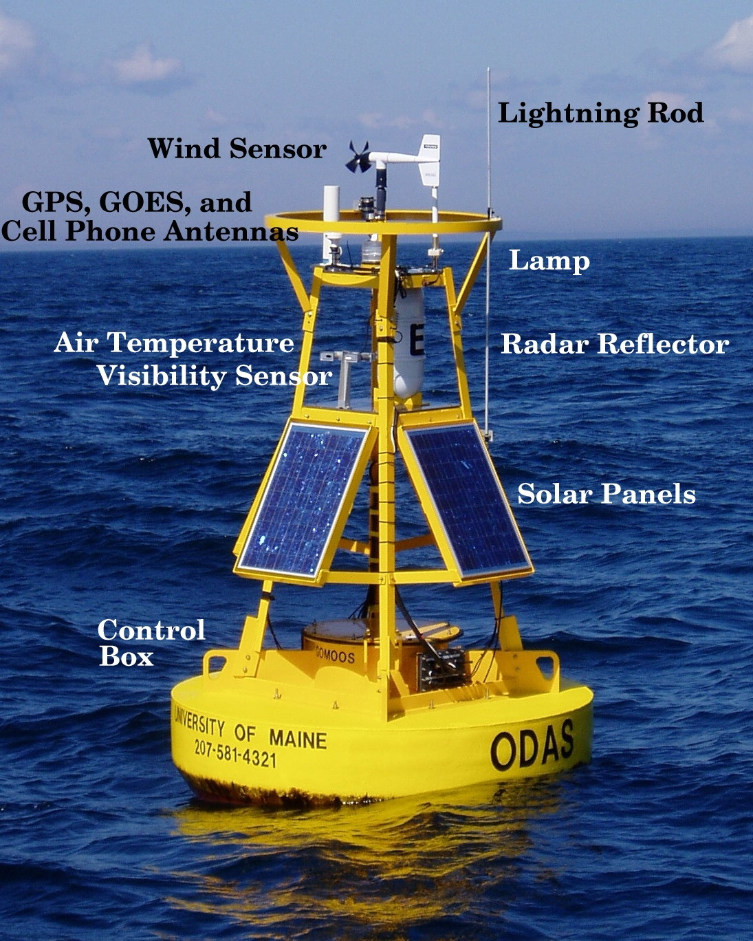
Fig. 2. The typical GoMOOS buoy with standard sensor suite. Not pictured are the base and mooring bail assembles.
The base, well assembly, solar panel mounts, tower, and guard ring were constructed from 6061-T6 aluminum. For added strength, the mooring bail was fabricated from mild steel. All pieces were coated with a two part epoxy marine paint for corrosion protection and then covered with a two part epoxy UV resistant marine polyurethane to reduce fading. A peroxide paint was applied to the subsurface members in an effort to reduce biofouling. The flotation was constructed from Surlyn® foam, manufactured by the Gilman Corp. The foam is lightweight and the manufacturing process makes this material well suited for axis symmetric design. The manufacturer shaped the foam to the hull specifications, and bored holes through the material without compromising the buoyancy

.

Perhaps the most important of the design criteria is the hydrodynamic stability and response. The buoy had to support the added moments of a service technician, additional weight from ice build up on the superstructure, and drag from surface winds. While the principle elements determining the seakeeping abilities of the buoy were determined by the hull design and buoyancy and weight distribution, great flexibility was add by incorporating a ballast tube at the bottom of the well assembly. The ballast tube provides easy access for adding the required weight to counter balance the effects of added moments or high wave activity. As an added benefit, the removal of ballast allowed the buoy to be used in differing mooring configurations. The flotation diameter-to-height ratio of approximately 3:1 provides an estimate for the stability under these constrains. The flotation hull was chined appropriately for towing the buoy at several knots, yet small and light weight enough to transport on a trailer.
The design stability criteria were chosen for the worst case scenario of a buoy adrift, without the stabilizing influence of the hanging cable and chain. In the event of losing its mooring cable, the buoy had to remain an upright and stable platform to ensure communications for tracking purposes and recovery. In order to design a buoy with these characteristics, a historical wave environment analysis of the Gulf of Maine using the NDBC data archive during the years spanning form 1979 to 1993. It was determined that the dominant annual averaged wave period was approximately 6 to 7 seconds with a maximum of 34 seconds and the annually-averaged significant wave height was 2 meters with a maximum of 10 meters. To avoid a near-resonant response, the natural buoy roll period had to be shorter than the dominant wave periods. The resulting buoy has a “stiff” righting moment with wave- rider properties.
At this point in the design phase, preliminary dynamic analyses of existing buoy designs were performed. The WHOI GLOBEC [3] buoy had shown, with some modifications, that a similar design could incorporate the payload need for the GoMOOS buoy and satisfy the general stability design criteria. The first step in the iterative analysis process was to develop a spreadsheet for calculating the weight schedules of the various components of the buoy, translate them into point masses in the buoy coordinate system, estimate the flotation size and shape and calculate the center of gravity, center of buoyancy, righting moment, natural frequency of roll, a water line and freeboard height. The spreadsheet results were further refined using a software product entitled BuoyCAD®. This program was well suited for axis symmetric buoys with point load inputs, and provided a hydrodynamic stability analysis and curves of form for a given design with the added moments discussed above. Figure 3 shows the resulting GoMOOS buoy stability results. The integration of righting moment verses degree heel estimated the amount of energy needed to capsize the buoy. Based on this analysis, the buoy would have to roll approximately 103º before capsizing. The estimated natural period of roll is approximately 2-to-3 seconds-well below the mean dominant wave period in the Gulf of Maine.

III. MOORING DESIGN

Based on ten years of deploying various types of moorings in the Gulf of Maine, it was concluded that a modified slack chain mooring is suitable for the near coastal gulf. The use of minimal equipment and components resulted in the reduction of man hours needed for preparation, standardized the design for the sites, and improved their survival of periodic entanglements with fishing gear and the rigorous environment. This design also allowed the reuse of mooring components because the entire mooring, including anchor and chain, was recovered for each turn-around operation.
The strength of the components was estimated using numerical techniques based on a hypothetical site that incorporated all the “worst case” scenarios from each mooring location around the Gulf. We developed in-house software for calculating the hydrostatic load for the components in various tidal and wave regimes. In order to estimate the dynamic loads on a given mooring, we used a Matlab® based package entitled Mooring Design & Dynamics [4]. A schematic of a typical mooring is shown in Figure 4.

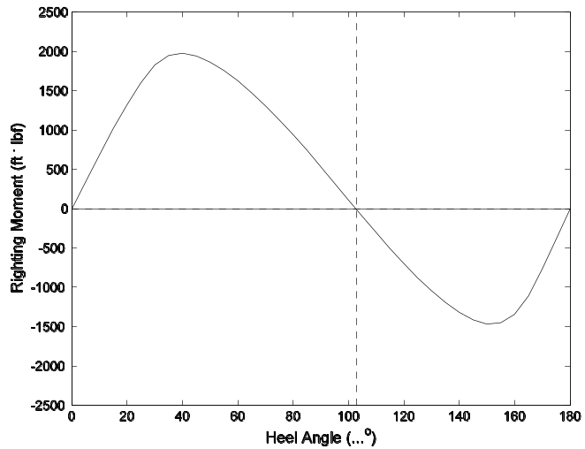
Fig. 3. Righting moment as a function of heel angle. The angle at which the buoy will capsize is 103º.
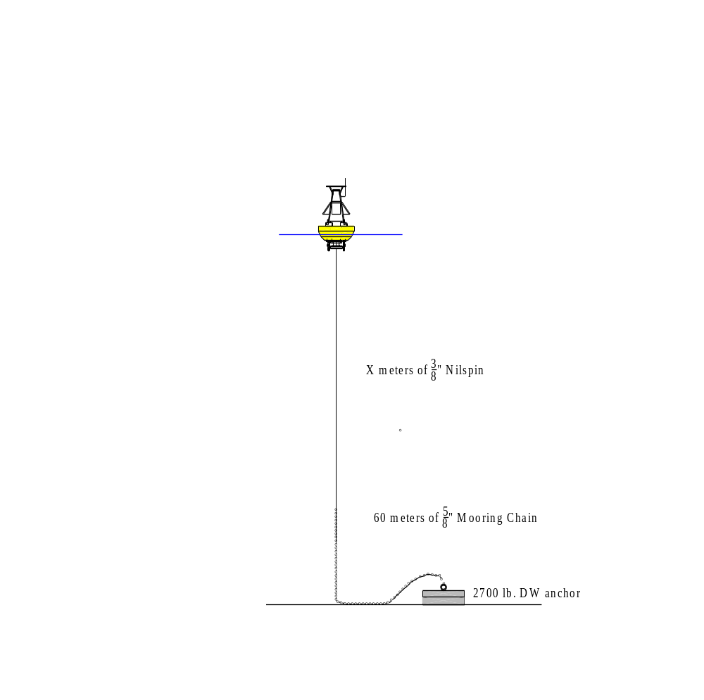
Fig. 4. The typical GoMOOS mooring schematic. The length of the 3/8” Nilspin is varied according to sites depth, wave, and tidal range.

Once the tensions on the hypothetical mooring components were determined, the standardized chain size and length, connecting hardware, and anchor weight were determined. Then, by simply adjusting the length of the wire rope, the scope of any mooring was determined to fit a particular mooring depth, wave and tide regime. This design removed the need to prepare and designate many components to a mooring for a particular location, and allowed us to swap components between mooring sites as needed. The standard wire diameter allowed the convenience of interchangeable clamp-on instruments.

IV. INSTRUMENTATION AND DATA FLOW

Since GoMOOS is a diverse observational program, each mooring is equipped with a standard suite of instruments, and site specific senors. Standard surface measurements include a meteorological package consisting

of an R.M. Young wind sensor measuring wind speed and direction, an Aanderaa visibility sensor for estimating localized visibility and sea smoke, and a Campbell air temperature sensor. Wave parameters are estimated by an onboard fixed-axis accelerometer. Ocean measurements include a Seabird microcat measuring temperature and conductivity mounted on the base of the buoy at a depth of 1 meter, and an Aanderaa RCM-9current meter measuring current velocity at 2 meters. The shelf and basin moorings also have a 300 kHz RD Instruments Doppler current profiler which measures current velocities in 4 meter bins from 10 meters to near-bottom. Inductive modems are used to relay subsurface temperature and conductivity measurements (typically at 20 and 50 meters) to the data logger. Additional inductive sensors at selected sites include dissolved oxygen (buoys A and C) and transmissivity (buoy K) (See Figure 1 for locations). Optical sensors for Bigelow Laboratory for Ocean Science mounted on the mooring and at 3 and 18 meters to monitor chlorophyll and multi-wavelength light penetration and attenuation (buoy B, E, I, and M).
All sensors are interfaced to a Campbell data logger inside sealed electronics box within the well of the buoy. Independent GPS systems for both cell phone and GOES provide position information as well as time synchronization. Data measurements are transmitted via cellular telephone (primary link) as well as through the GOES satellite system every hour. The software within the data loggers include alarm checks on position, leak detection in the well, and power fluctuations. The data are processed and preliminary quality control checks are performed at the University of Maine and are then transferred to the GoMOOS project office for posting on www.GOMOOS.org. Data from the GoMOOS moorings are also distributed by NOAA’s National Data Buoy Center’s coastal monitoring program.

V. CONCLUSION

The GoMOOS moored buoy array became operational in July of 2001 with the deployment of nine buoys and the final tenth buoy was deployed in September of that year. Over the following 2 years, the University of Maine and Woods Hole Oceanographic Institute have maintained the array involving about 33 separate cruises (lasting from 1 to 7 days) on 11 different vessels.
Future plans for the buoy array include adding a buoy in the Northeast Channel to monitor the inflow of slope water to the gulf, and new sensors, including the ECOLAB nutrient analyzer to monitor the deep inflow of inorganic nutrients through the Northeast Channel, a Flow-CAM to count and size particles and identify phytoplankton, hydrophones to track Right Whales, and additional senors to further study buoy dynamics and estimate directional wave spectra.

Acknowledgements

This work was supported by the Office of Naval Research under contract number N00014-01-1-0999. We would like to thank all the captains and crew from the various research and fishing vessels who so patiently watch us “mill about” during the mooring cruises.

REFERENCES

[1] Garrett, C., 1972, Tidal Resonance in the Bay of Fundy and Gulf of Maine. Nature. Vol. 238, No. 5365, pp. 441-443.

[2] Brooks, D., 1985, Vernal Circulation in the Gulf of Maine. J. Geophys. Res., Vol. 90(C5), pp. 4687-4705

[3] Irish, J., W. Paul, J. Shaumeyer, and C. Gaither III, 1999, Next-Generation Ocean Observing Buoy. Sea Technology. Vol. 40, No. 5, pp. 37-43.

[4] Dewey, R., 1999, Mooring Design & Dynamics. Marine Models Online. Vol. 1, pp 103-157.

